The Effect of Immigration and the Military on Asian American Voter Behavior

by
Claire Knystautas

A Senior Honors Thesis Submitted to
the Department of Political Science,
University of California, San Diego

April 2, 2023

Acknowledgements
To Professor Karen Ferree, thank you for being the best advisor I could hope to have for this thesis. Your encouragement helped push this project beyond what I believed myself to be capable of and this thesis would not have developed into what it is today without your generous support, invaluable feedback, and staunch encouragement.
Thank you to Professor Fonna Forman and Professor Germaine Hoston for leading the honors seminar and for establishing a strong foundation for myself and my classmates to begin our theses. Thank you to Mr. Theodore Dounias for support in R; you solved issues in minutes that would have taken me hours to unravel.
A thousand thank-yous to my friends who bring joy to my life and have given me the motivation to push through every challenge that emerged over the course of this project.
And to my wonderful family; thank you for allowing me the room to experiment and grow over the last four years at UC San Diego. Everything that I have accomplished is a tribute to your love and the sacrifices you have made to allow me the privilege of this academic journey.

The Effect of Immigration and the Military Exposure on Asian American Voter Behavior

Table of Contents

Acknowledgements………………………………………………………………………………..1
Table of Contents………………………………………………………………………………….3

Chapter 1: Introduction……………………………………………………………………………4
Chapter 2: Literature Review………………………………………………………………….......9
Chapter 3: Argument and Hypotheses…………………………………………………………...15
Chapter 4: Research Design……………………………………………………………………...19
Chapter 5: Results and Analysis…………………………………………………………………25
Chapter 6: Discussion……………………………………………………………………………36
Chapter 7: Conclusion……………………………………………………………………………42
References………………………………………………………………………………………..44
Appendix A. Survey Instrument…………………………………………………………………47
Appendix B. Survey Flyer……………………………………………………………………….59

Chapter 1: Introduction

Asian Americans tend to vote for Democrats over Republicans; however, this pattern is not uniform. What explains the variation in Asian American support for Democrats? Previous work has focused on ethnic subgroups of Asian Americans as a means of explaining this trend. “Asian American” is a pan-ethnic label that encompasses a variety of subgroups with different regional and cultural backgrounds. Differences in voter behavior are often explained along ethnic lines; existing research on Asian American voter behavior shows that while the majority of Asian Americans vote Democratically, there are specific ethnic subgroups like Vietnamese and Filipino Americans who consistently vote for Republicans at higher rates (Ramakrishnan et al. 2016). This thesis instead focuses on two different factors: intergenerational diversity in immigrant status and military exposure.
Asian immigration to the United States has increased dramatically over the last century. In the 1950s, Asian immigrants made up 5% of total admissions to the U.S., but by the 1980s this number had increased to around 35% (Zhou et al. 2016). Asian immigration to the U.S. has remained at a relatively high rate since the 1980s and is a key factor in the rapidly growing Asian American population (Zhou et al. 2016). This drastic population increase has been accompanied by increased diversity within the Asian American community, including greater diversity in national origin, immigrant generation, and socioeconomic status (Wong and Shah 2021).
Existing American political socialization literature focuses on a narrow demographic with limited research on the nuances of additional factors like race, ethnicity, or the multicultural experience that is relevant to many immigrant groups within the U.S. face. Political socialization theory states that the events that occur during early adulthood play a defining role in establishing the political attitudes that individuals will hold for the rest of their adult lives (Osborne et al. 2011). If this is true, then families with different generations of immigrants may be particularly diverse in terms of their political views due to differences in the dominant culture of the country in which each family member spent their formative years. Research on these differences can help inform political mobilization strategies that target Asian Americans and potentially combat historically low turnout rates among eligible Asian American voters.
In addition to immigration status, war and military involvement introduce another dimension in understanding variation in Asian American political views. According to data from the 2020 Asian American Voter Survey, a majority of Asian American voters self-identify as Democrats, but this is not universal for all groups and ethnicities that fall under the Asian American label (APIAVote 2020). Indian, Japanese, and Korean Americans have the highest percentages of Democrats (Do 2020). In contrast, Filipino and Vietnamese Americans, both Southeast Asian groups, have the highest percentages of Republicans (Do 2020). This pattern can be partially traced back to the U.S. military intervention shaped the immigration channels between Southeast Asia and North America, and by extension, the processes of assimilation and adaptation for Southeast Asian migrants in their new homelands (Bankston & Hidalgo 2016).
Since 1980, the Philippines and Vietnam have made the list of top ten sending countries of immigrants to the United States (Zhou et al. 2016). The United States’ occupation of the Philippines from 1898 to 1946 marked the first instance of U.S. military activity in Southeast Asia and resulted in the first waves of Southeast Asian immigration to the United States, largely in the form of Filipina military spouses to U.S. servicemen (Bankston & Hidalgo 2016). Many Filipino and Vietnamese Americans still have close ties with the U.S. military; common manifestations of this trend include familial ties to servicemen and women, or close geographic proximity to a military base for occupational and historical migration reasons. Understanding how these historic relationships interact with the experiences of current Filipino and Vietnamese Americans is key to explaining the Republican outlier in a majority Democratic demographic.
In this thesis, I examine the variation in Asian American political views across two different fronts: generational differences between immigrants, and military exposure. Do the political views of younger generations of Asian Americans deviate significantly from their older counterparts? Do native-born Asian Americans have different attitudes than new immigrants? What is the effect of contact with the U.S. military, or close proximity to a military base on the political views of Asian Americans? In addition to inherited views about the U.S. military from Asian countries and their historical relationships with the United States, how might socialization near military bases affect the political views of younger generations of Asian Americans?
My argument centers on four main hypotheses, two of which pertain to the generational factor and two that pertain to the military factor. I hypothesize that (1) younger generations of Asian Americans will have more liberal views than their older counterparts, (2) the gap in political behavior between older and younger Asian Americans will be greater among those with more recent contact with immigration, (3) Asian Americans with greater contact with the U.S. military will have more conservative views, and (4) the intergenerational gap in political views is smaller for Asian Americans with close military contact than for those without close contact.
I expect exposure to immigration or the presence of multiple generations of immigrants to exacerbate the tendency of younger Asian Americans to be more progressive and support Democrats at higher rates than their parents. There are a relatively high number of foreign-born Asian American adults compared to other racial or ethnic groups in the U.S. On average, Asian American families are more likely to experience more extreme generational differences than other communities because of experiential differences caused by immigration status. Political socialization theory does not account for situations where there are extreme experiential differences between generations of parents and children, and I hypothesize that these greater differences will cause younger generations to deviate more from the political behavior of their parents.
In contrast, I expect military exposure to act as an insulating factor that reduces the Democrat-inclined tendencies among younger Asian Americans. Unlike immigration which causes greater variety in the process of assimilation between older and younger generations, military exposure typically affects multiple generations uniformly. Military exposure in the United States is not a uniquely Asian American experience; past data shows a negative correlation between military exposure and Democrat-inclined behavior among younger Americans of other races, so I expect to see a similar pattern among younger Asian Americans who have more military exposure.
I begin with a brief overview of the history of Asian immigration to the United States, concentrating specifically on how war and military intervention have played a prominent role in shaping immigration channels between Asia and the United States. My research methods will utilize data from the Collaborate Multi-racial Post-election Survey (CMPS), a questionnaire distributed to voters following the 2016 election cycle. The CMPS includes data on party preference and voting behavior in the 2016 presidential and congressional election from respondents broken down into subcategories based on race, ethnicity, and national origin.
My findings on the relationship between immigration and political behavior align with existing literature and show that age is negatively correlated with voting Democratically in Asian Americans. From my interactions between the effects of age and immigration I find that the behavioral gap between older and younger voters is greatest among first generation immigrants, and that the length of time spent in the U.S. is positively correlated with the tendency to vote for Democrats. This introduces a new dimension to the study of Asian American political behavior, which does not usually differentiate between immigrant status and the amount of time an individual has spent in the United States, specifically how these two factors work in combination to affect voter behavior. This finding supports my theory that the way immigration interacts with the process of political socialization during one’s formative years is more significant than traditional measures of immigration, like being foreign-born versus native-born.
Similarly, I find that military exposure is negatively correlated with voting Democrat. However, I find that more military exposure exacerbates the behavioral gap between older and younger Asian Americans rather than having an insulating effect on intergenerational political behavior. Among recent immigrants, there is an increased likelihood of younger Asian Americans deviating from older generations in their political behavior. Families with more recent ties to immigration will likely have greater differences in formative experiences, which are key factors in political socialization and the development of political behavior. The same argument could be applied to military exposure.
The Asian American population has increased significantly at a constant rate over the last half-century. As Asian American communities become more established and diverse, it becomes easier to study the effects of immigration status and military exposure on the processes of assimilation and political socialization. By these two key factors I introduce a novel lens to study these phenomena through. In this thesis I attempt to provide a more accurate explanation for the diversity in voter behavior that defines the Asian American community.

Chapter 2: Literature Review
To study the unique ways that intergenerational relationships and immigration affect Asian American voter behavior, one must first be familiar with political socialization and the role that family plays in the process of political socialization. The impressionable years hypothesis states that there is a period during early adulthood when individuals are most prone to changes in their sociopolitical views (Osborne et al. 2011). The events that occur during this period typically play a defining role in establishing the political attitudes that individuals will hold for the rest of their adult lives (Osborne 2011). As people age, their sociopolitical views stabilize, and they are unlikely to deviate from the attitudes they developed during late adolescence or early adulthood (Alwin & Krosnick 1991). Existing literature on political socialization says that familial relationships are the best predictor of the political attitudes of an individual. In Andrew Greeley’s, “A Model for Ethnic Political Socialization,” he states that ethnic subculture, social class, family structure, and political values of the parents are the most important predictors for a child’s political values (Greeley 1975). While definitions of ethnicity have shifted in America in the years since Greeley’s study, parental views are still generally regarded as the primary factor in political socialization today. This creates an interesting point of study for immigrant families: raising children in a new country creates an opening for conflict between the cultural values of the parents and those of the society their child is submersed in.
The number of foreign-born adults living in the United States has increased dramatically over the last few decades. As of 2019, there were approximately 44.9 million individuals living in the United States who were born in another country, constituting roughly 13.7% of the population (Frey 2022). Data from 2018 found that the largest immigrant populations in the U.S. are from Mexico, followed by India, China, excluding Hong Kong and Taiwan, and the Philippines (Frey 2022). Statistically, because there are more foreign-born Asian American adults than any other major racial demographic in the United States, there will be more Asian American families with multiple generations of immigrants within the same immediate family. I define immediate family as the nuclear family unit of parents, children, and the potential addition of one or two sets of grandparents. In other words, many Asian families currently living in the United States must contend with generational differences within their family unit and broader ethnic community based on both age and immigration status. This creates a new dimension of study for the process of political socialization that was not relevant to political scientists studying primarily Anglo-American families in the second half of the twentieth century, and as such, requires further research in the future.
The process of immigration often includes certain pressures to assimilate that affects different generations of immigrants non-uniformly. Key factors that determine how an individual experiences the pressure to assimilate are 1) the length of time they have spent in their new host country, and 2) the age at which they immigrated to a new host country. Ideological or cultural differences could emerge between Asian American parents and children as the result of different generations of families spending their formative years in different countries. In some cases, younger generations of Asian Americans might have significant incentive to deviate from the political attitudes of their parents as part of the process of assimilation.
Dyogi Philips and Lee (2016) found significant evidence that there are differences between the voting behavior of foreign-born and native-born Asian Americans: foreign-born Asian American men and women are less likely to contact elected officials than native-born Asian Americans, and foreign-born Asian American women are less likely to vote than their native-born counterparts (Dyogi Philips & Lee 2018). This study also suggested that there are differences in political behavior between Asian American men and women that were especially significant when comparing foreign-born men and women. The processes of immigration and political socialization are gendered, and in the case of Asian American women this gendered element is revealed in political participation rates. For Asian American women, being foreign-born is negatively correlated with political participation, despite other factors like higher education achievements and upper-middle class socioeconomic status that would typically predict higher rates of participation (Dyogi Philips & Lee 2018). Since this pattern was not observed in Asian American women who were born in the United States, this supports the idea that Asian American parents and children within the same families who are different generations of immigrants will receive and internalize different messages from society and family during their formative years. Furthermore, this study suggests that different values or priorities during socialization will likely affect the political behavior, including voter behavior, of individuals within the same racial and gender group.
Over the last decade, the term “1.5 generation” immigrant has emerged as the number of immigrants living in the United States has increased. A 1.5 generation immigrant is defined as an individual who immigrates to a new country at an early age and subsequently comes of age in their host country (Zhou 1997). The experiences of 1.5 generation Asian Americans are distinct from their first-generation parents who spent the entirety of their formative years in their home country. They are also distinct from the experiences of younger generations, second-gen immigrants and beyond, who were born in the United States and considered natural citizens from birth. We might expect the political ideology of 1.5 generation immigrants to fall somewhere in between first and second-generation immigrants, depending on how early in adolescence a 1.5-gen individual immigrated and how many of their formative years were spent in the United States versus their home country.
To supplement this research on how socialization helps to create behavioral differences between generations of immigrants, I turn to the field of psychology. Modern psychological research finds that a focus on education and academic achievement continues to be defining characteristics in the upbringing of many Asian Americans. This emphasis on education holds true for multiple generations of Asian Americans, and some scholars have attributed this phenomenon to the lasting effect of Confucian culture, even long after immigrants have settled in a new country (Model 2020).
Another study on intergenerational family conflict found that most conflict between Asian American college students and their parents stemmed from value discrepancies such as conforming to family norms or education and career issues (Tsai-Chae & Nagata 2008). These sources of conflict arise as later generations of Asian Americans seek to reconcile traditional family values with the dominant culture, which provides another inflection point for research into differences in political attitudes that emerge between generations of Asian Americans. There is also research on the process of ethnic-racial socialization and ethnic-racial development that suggests that racially marginalized communities such as the Asian American community uses shared trauma to create a common identity (Cai & Lee 2022). This can help to explain similarities between multiple generations of Asian Americans that sometimes persist despite profound differences in socialization between first, second, and third generation immigrants.
Another key component of my thesis is the ways in which military affiliation or proximity to a military base affects the political affiliation of Asian American voters. At this point in time, there is insufficient research on this topic, particularly in terms of the role of the military on voting behavior. Asian Americans typically vote more Democrat candidates over Republicans, except for certain ethnicities within the Asian American label, such as Vietnamese and Filipino Americans. However, there is limited information on how much that is directly due to military factors, beyond the U.S. military’s influence in shaping Asian migratory trends starting in the second half of the twentieth century (Bankston & Hidalgo 2016). Data on the location of military bases in the United States shows that there is a higher number of bases in several states with higher Asian populations, including California (Menegus 2019). The location of bases is partly determined by the population of the surrounding area, which helps to explain why there are a significant number of bases in California, the most populated state in the U.S. However, relevant to this project, there is some overlap with areas that historically have higher concentrations of Asian Americans relative to the rest of the country, such as Miramar in San Diego, CA (Menegus 2019).
Military enlistment has historically been one of the primary channels of assimilation offered to Asian immigrants in the United States. The relationship between the U.S. military and Asian immigrants dates back to the end of the 19th century when the only form of immigration to the United States came in the form of Filipinos who had enlisted in the U.S. Navy (Bankston & Hidalgo 2016). For some Asian Americans, involvement with the U.S. military might be perceived as a means of legitimizing their status as an American. Alternatively, enlistment in the military could be an easily accessible form of guaranteed employment for recent Asian immigrants or disenfranchised Asian Americans already living in the United States.
Regardless of the specific reason behind an individual’s choice to enlist or involve themselves with the U.S. military, military exposure is intrinsically linked with the immigrant journey for many Asian Americans and is another channel through which to study the ways in which immigration and assimilation affect Asian American political behavior. This project will attempt to contribute to this lack of information and draw some connection between military influence and trends in Asian American partisanship, including the potential effects of close contact with the U.S. military on political ideology within Asian American communities.

Chapter 3: Argument and Hypothesis
There is not sufficient research studying the ways that immigration and military contact shape political behavior, specifically among Asian Americans. Immigration challenges existing literature about political socialization because of how the process of assimilation and acculturation interact with parental influence on socialization. For many Asian Americans, warfare or U.S. military involvement in their home country is a driving force behind immigration and is another factor that uniquely shapes the political socialization process. The historical relationship between the U.S. military and Asian countries continues to influence Asian Americans today, but there has not been sufficient work done to explain these influences, and how they interact with the process of assimilation. Specifically, how do they manifest in the political behavior of Asian Americans and how does the effect of military exposure compare with the effects of immigration.
Due to the complex nature of political socialization in immigrant communities and the influence of powerful institutions like the U.S. military, my hypotheses are as follows:

- Younger generations of Asian Americans will have more liberal views and tend to vote for Democratic candidates more than older generations within the same communities.

In the United States, younger generations tend to be increasingly liberal when compared to their older counterparts, and I expect to see this pattern in Asian Americans, specifically because of the effect of the dominant culture on younger generations of Asian Americans.

- There is a greater behavioral gap between older and younger Asian Americans who are recent immigrants than those with more distant ties to immigration.

I expect this association to be especially strong among native-born individuals or individuals who immigrated early in life and were primarily socialized in American culture. In families with either first- or second-generation immigrants, there will be greater differences in the style of political socialization that parents and children were exposed to in their formative years. Differences in political socialization and the dominant culture of the country where an individual spent their formative years could result in more pronounced differences in political behavior between generations. Additionally, within families who have recently immigrated to the U.S., the pressures of assimilation will be felt less uniformly within families and potentially contradict political socialization theory that emphasizes the role of the parents on political development.

- Asian Americans with more exposure to the U.S. military will have more conservative views and vote for Republican candidates more than Asian Americans without military exposure.

Apart from the most recent presidential election in 2020, data from past elections shows that military service members usually hold conservative political beliefs and are more likely to support Republican candidates (McCarthy & Richter 2020). I expect to find a similar association between political ideology and military affiliation when specifically viewing data on Asian Americans. There is a greater tendency for ethnic subgroups of Asian Americans with more service members to have higher rates of support for Republicans or a larger proportion of individuals who identify with conservative values.

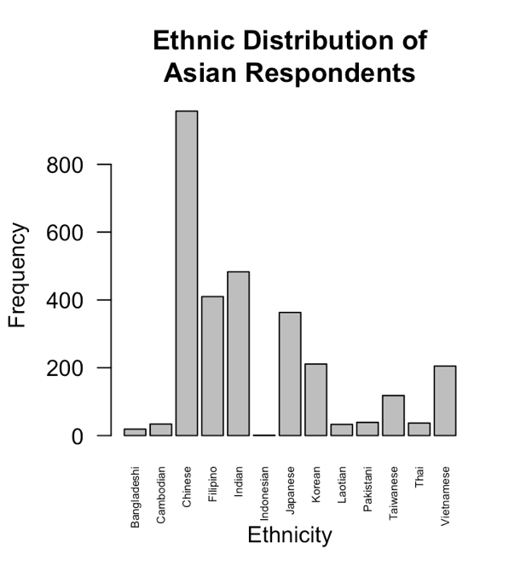
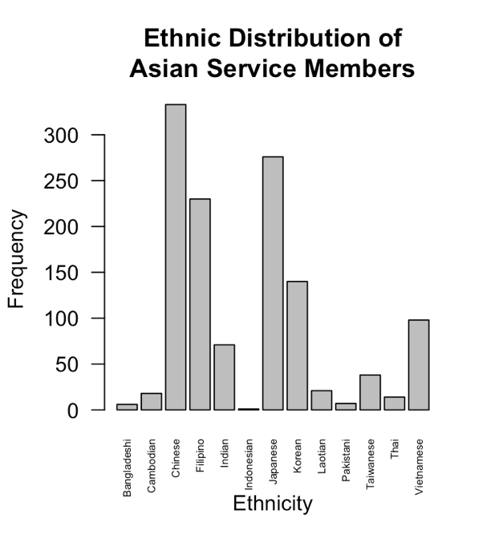
Figure 1: Ethnic Distribution of Respondents, CMPS 2016

As seen above in Figure 1, data from the 2016 Comparative Multi-racial Post-election Survey shows that several ethnic subgroups, including Filipino, Vietnamese, Japanese, and Korean Americans have proportionally more active and retired U.S. service members (Frasure et al. 2022). This overlaps with party identification data from the 2016 National Asian American Survey that finds the highest percentage of Republicans among Japanese Americans, followed by Filipino, Cambodian, Korean, and Vietnamese Americans (APIAVote et al. 2020).

- Having close contact with the U.S. military reduces the differences in political behavior between older and younger generations of Asian Americans.

It is my hypothesis that close contact with the military will act as an insulating effect against the general trend of increasingly liberal views among younger generations of Americans. I define “close contact” as contact that exists through a social connection between an individual and an active or retired service member, i.e., a familial relationship. I expect that closer contact, such as an individual being a service member themselves or having a parent who was a service member at some point in their life, to have a more insulating effect on political behavior.

Chapter 4: Research Method
  - Data
To study the differences in political ideology between generations of Asian Americans I use the Comparative Multi-racial Post-election Survey from 2016, focusing specifically on respondents who self-identified as Asian American. This dataset includes responses from over 10,000 individuals who voted in the 2016 election, roughly 3,000 of whom identified as “Asian.” The CMPS questionnaire can loosely be categorized into two sections: questions on respondents’ political attitudes and behaviors and questions on the lived experiences of respondents as it pertains to issues of race, economic conditions, and polarizing social issues like immigration.
Two key strengths of the CMPS that are most applicable to my research questions are (1) the variety that is included in the ethnic breakdown of respondents who identified as “Asian” and (2) the level of detail in the section on the respondents’ relationships with active and retired service members of the U.S. military.
There is also data included on the immigration status of each respondent, including who was the first person in their immediate family to immigrate to the U.S., themselves, parents, grandparents, etc., and the date that this immigration happened. This information is key to studying the immigration dimension of my hypothesis, but the data itself is more limited as most respondents are either first- or second-generation immigrants to the United States. Ideally there would be a little more variety in the responses and include people whose grandparents or great-grandparents were the most recent immigrants within the family to better compare the behavior of Asian Americans who are removed from immigration to recent immigrants. Another limitation that I planned to address using my survey is the lack of data on the intergenerational composition of the household. Without that data, I am unable to test how living with more than two generations within the same household affects the political socialization of younger generations of Asian Americans.
Furthermore, this dataset only includes data from respondents who voted in recent elections which demonstrates a certain level of political awareness and eliminates Asian Americans who are not able or willing to vote. An inability or unwillingness to vote could be attributed to issues with citizenship or English language proficiency, both of which are likely to affect Asian Americans more than other racial groups within the U.S. due to the high number of the adult population that are immigrants (Zhou et al. 2016). That said, since I am primarily interested in studying voter behavior, the CMPS should provide sufficient data to begin examining the effects of immigration and the military on Asian American voters specifically.
  - Immigration
My analysis on the relationships between age, length of U.S. residency, immigration status, and voting behavior will consist of a series of Ordinary Least Squares (OLS) linear regressions. For the purposes of this project, I am concerned with generational behavior differences that result from age gaps as well as socialization gaps between immigrants and native-born Asian Americans. To test this, my independent variables include the actual age of the respondent as well as two variables to measure immigration: (1) immigrant, how removed an individual is from a first-generation immigrant to the U.S. and (2) respercent, the percentage of a respondent’s life that they have lived in the U.S.
I created the variable, immigrant, using data on whether the respondent, the respondent’s parents, or the respondent’s grandparents were born in the United States. I created an ordered variable, immigrant, with values ranging from 1-4; the lowest value, 1, indicates that a respondent themself immigrated to the United States and has the fewest degrees of separation from a first-gen immigrant.
For the variable, respercent, I used data on the age of the respondents, whether they were born in the United States, and if they were born in another country, the year they immigrated to the U.S. I used a basic percentage formula to find a percentage out of 100 that represented the time respondents had lived in the United States relative to their total lifespan as of 2016, and then created an ordered variable, respercent, from those percentages. The ordered variable includes values from 1-8, with higher values indicating a higher percentage of life lived in the United States.
My dependent variable measures the amount of support for Democratic candidates in the 2016 election cycle in both the presidential and congressional elections. I created two variables, DEM and dem to differentiate between levels of support for Democrats. DEM includes individuals who voted unanimously for Democrats in both presidential and congressional elections, while dem includes all respondents who voted for at least one Democrat in either election. I want to differentiate between levels of support for Democrats to consider irregularity from the 2016 election and relatively low support for Hillary Clinton compared to Democratic presidential candidates from other years.
As the result of significant increases in immigration rates from Asian countries to the U.S. in the second half of the 20th century, older generations of Asian Americans are more likely to be first- or second-generation immigrants to the United States than younger Asian Americans. To isolate the effect of age on voting for Democrats, I include my two immigration variables as controls in the OLS first regression.
To control for behavioral differences between ethnic subgroups, I included dummy variables for each primary subregion of Asia in the linear regressions. The CMPS allowed Asian American respondents to specify their primary ethnicity or family background from the following list: Bangladeshi, Cambodian, Chinese, Indian, Iranian, Japanese, Korean, Laotian, Pakistani, Filipino, Taiwanese, Thai, or Vietnamese. I created dummy variables using this data and categorized individuals as East, Southeast, or South Asian. I excluded responses that did not specify an ethnicity or chose to write in an alternative ethnicity not listed in the options above. I also included a dummy variable to control for possible differences in voter behavior between men and women. The CMPS offered respondents the option of selecting “male” or “female” for their gender, so I created the variable, gender, where 1 represents a female respondent and 0 represents a male respondent.
  - Military Contact
To estimate the effect of military contact on voting behavior I will run two more OLS regressions, one that measures the effect of military contact alone on voting Democratically, and one that introduces an interaction term between the effect of age and military contact.
I will use the extensive data included in the CMPS on respondents’ relationships with service members of the U.S. military for this portion of the analysis. I created an ordered variable, military, that categorized the respondents’ degree of contact with active or retired service members from and assigned values 1-4. A respondent was assigned the value “1” when the respondent themself was a service member, marking what I define as the highest possible degree of contact with the military.
The dependent variables are the same two measures of voting Democratically, DEM and dem, as the previous section and I will once again include ethnic controls based on regional differences between respondents as outlined in Section 4.2.
  - Limitations & Original Survey
My original plan for this project was to collect data by distributing an original online survey to Asian Americans based in Southern California, but I was unable to distribute this survey because of delays in the Human Subjects Review process. The survey included questions about the respondents’ demographic attributes, political attitude and behavior, and the degree of contact with the military (see Appendix A). I planned to distribute this survey primarily through AAPI student organizations at the University of California, San Diego, and through an additional social network of Asian American friends and family around Southern California. I programmed the survey in Qualtrics and prepared a flyer with a QR code and link to the survey for more convenient distribution (see Appendix B).
The results would have provided novel data on the relationship between the military and political behavior in Asian Americans, as well as the effect of intergenerational household status on political socialization and political behavior. I began the process with the help of my advisor and first submitted my survey to the UC San Diego Institutional Review Board in November 2022, but several bureaucratic delays occurred during the process, and I was unable to secure approval in time to distribute the survey for this project.
The primary limitation of relying on the CMPS rather than my own data is the lack of location-specific data on respondents. My original plan for measuring military contact included studying the effect of living within close geographic proximity on an individual, separate from any relationships they might have with active or retired service members (see Appendix A). This geographic component would help isolate the effect of living in a military area on political behavior for individuals without other military contact. It would also provide an interesting point of comparison between individuals without military affiliations who live near bases and those with preexisting military connections who moved near a base because of those connections.
My survey instrument included geographic information at the zip code and city level, as well as the motivation for moving to the current primary address of each respondent (see Appendix A). I also included a line of questioning about the respondent’s personal experiences with war in their home country and how that experience may have affected their family’s decisions to move to the U.S. If a respondent indicated that fleeing war was their family’s primary reason for immigrating, I included further questions specifying whether war or military involvement was a key factor in the respondent moving to a specific area within the United States, i.e., an area near a military base.

Chapter 5: Results and Analysis
  - Age and Immigration Status
Using data from the Comparative Multi-Racial Post-Election Survey and regressing voter behavior against age, immigration status, and the interaction between age and immigration, I find support for my first two hypotheses regarding immigration.
Figure 2 shows that the probability of an individual voting for at least one Democrat in 2016 decreases by 0.3% per additional year of age. This supports my first hypothesis that older Asian Americans are less likely to vote for Democrats than younger generations, regardless of if they are recent immigrants or have lived in the U.S. for most of their lives.
There is also a positive relationship between the percentage of a person’s life lived in the United States and the likelihood of voting exclusively for Democrats in 2016, holding immigration status, regional background, and gender constant. For each additional percentage of total life lived in the United States, Asian Americans were 1.2% more likely to vote for Democrats in both the presidential and congressional elections in 2016. While this is not a large effect, it does show that individuals who have lived in the United States for longer are more likely to vote for Democrats.
Additionally, it is important to note that while it was not statistically significant, there was a negative correlation between Southeast Asian Americans and voting for Democrats in all the regressions run in Figures 1, 2A, and 2B. These results make sense in the broader context of Asian American voting patterns; in a mostly Democratic-leaning group, Southeast Asian groups like Filipino or Vietnamese Americans have the highest proportions of Republican voters.
In contrast, South Asians were more likely both to vote unanimously for Democrats and to vote for at least one Democrat in 2016 in all the regressions run in Figures 1, 2A, and 2B as seen on the following pages. Not all the coefficients on the South Asian dummy variable were statistically significant, but there was consistently a strong positive correlation between identifying as South Asian and voting Democratically. This also aligns with existing literature that states that South Asian American voters, specifically Indian Americans, have some of the highest levels of support for Democrats.
There is not a consistent positive or negative correlation for voting Democratically among East Asian Americans as there is for either Southeast or South Asians, which is also consistent with average data on the partisan breakdown of different ethnicities within the Asian American label.
Gender was another statistically significant control; for the regressions with DEM and dem in Figure 2, being a woman is associated with a 7% and 6.3% increase in voting Democratically, respectively. This is consistent with other data on Asian American voting behavior; surveys like the NAAS find that women consistently vote for Democrats at higher rates than men (APIAVote et al. 2020).
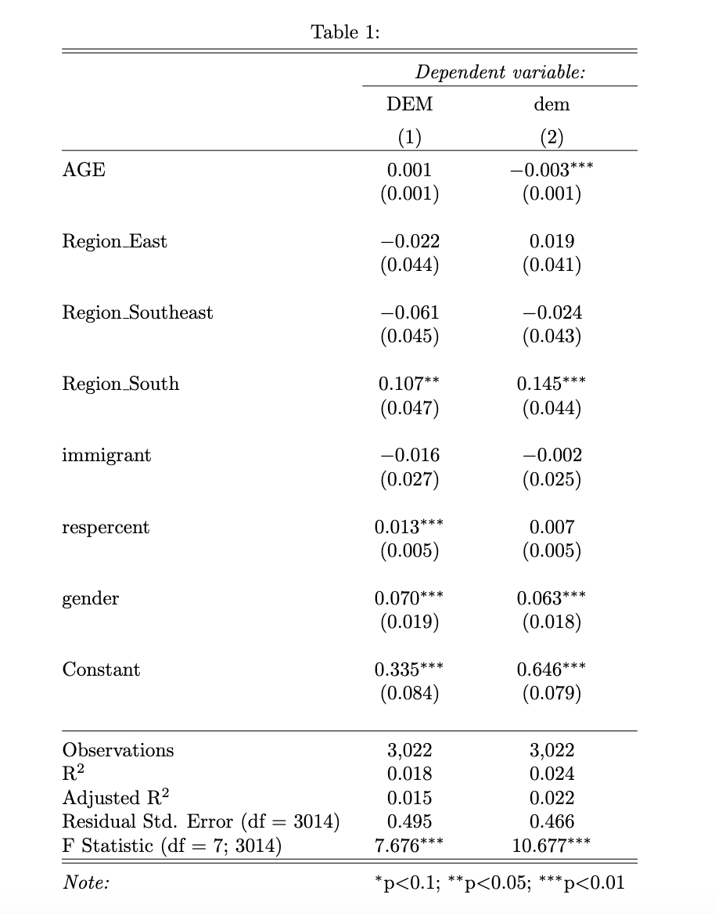
Figure 2: Effect of Age on Voter Behavior

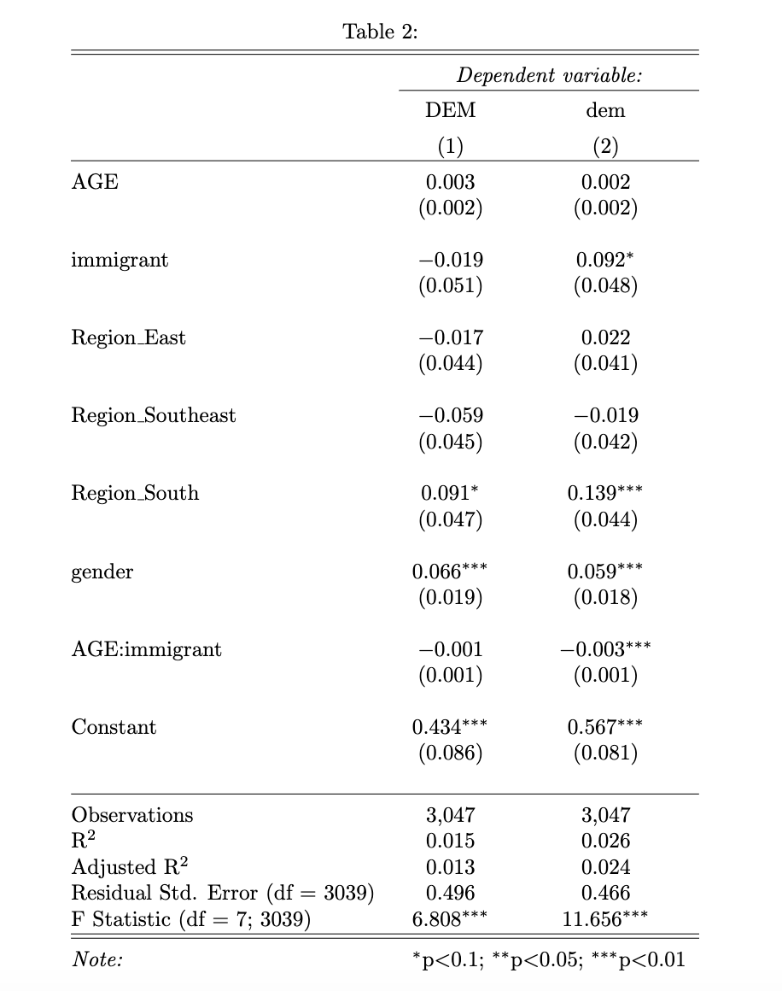
Figure 3A. Effects of Age and Immigration on Voter Behavior I

Figure 3A measures the effect of immigration on the effect of age on the voting behavior of respondents using an interaction term between age and the first of two different measures of immigration: the variable immigration measures the degrees removed an individual is from a first-generation immigrant to the United States. I ran two separate regressions with this interaction term to measure its effect on voting exclusively for Democrats in 2016 (DEM) and voting for at least one Democrat in 2016 (dem). The results were not uniform across these two regressions, and I found that the interaction between age and immigration status was a more significant predictor of voting for at least one Democrat (dem). For this portion of the analysis, I will focus on the second column of Figure 3A which shows the results of the regression run with dem as the dependent variable.
Looking only at the interaction term between age immigration status, the effect of age on voting behavior decreases among respondents who are further removed from immigration by 0.003-unit decrease. In other words, there is a larger behavior gap between older and younger Asian Americans among first generation immigrants than it is for second or third generation immigrants.
This supports my second hypothesis that among recent immigrants, younger Asian Americans are more likely to deviate from older generations in their voting behavior than Asian Americans who are further removed from immigration. This increased difference in intergenerational behavior among recent immigrants could be attributed to an increased likelihood of the parents and children of a family of first-generation immigrants growing up in different countries than a third-generation family. I will investigate this more in Figure 3B by studying the effect of age in combination with the percentage of life lived in the United States.

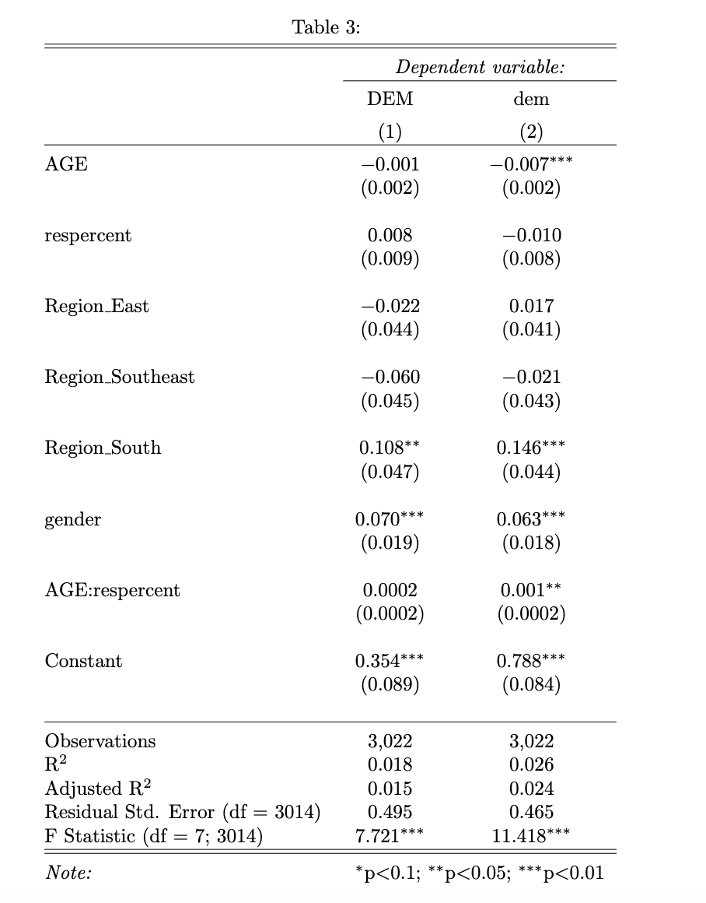
Figure 3B. Effects of Age and Immigration on Voter Behavior II

Figure 3B estimates the effect of immigration on the effect of age to predict voter behavior using another interaction term between age and the second measure of immigration, respercent, or percent of life lived in the United States. As with Figure 3A, it includes regressions on voting exclusively for Democrats and voting for at least one Democrat in 2016. I did not find statistically significant results for voting exclusively for Democrats (DEM) and will focus primarily on the results from the second column of Figure 3B.
The effect of age increases as the percent of residency in the U.S. increases for respondents who voted for at least one Democrat in 2016. This means that there is less variety in voter behavior between older and younger Asian Americans who have spent fewer years in the U.S. relative to their total life lived. Since older generations consistently vote for fewer Democrats, we can extend this and say that younger Asian Americans who have spent less of their lives in the United States tend to vote more conservatively than their same-age peers who have lived in the U.S. for proportionally longer periods of time.
This could be explained by the influence that pressures to assimilate and acculturate have on immigrants; regardless of if an individual is technically a first-generation immigrant, if they have spent most of their life and their formative years surrounded by American culture, they are more likely to mirror behavioral trends of other young Americans than of their parents.

  - Military Contact
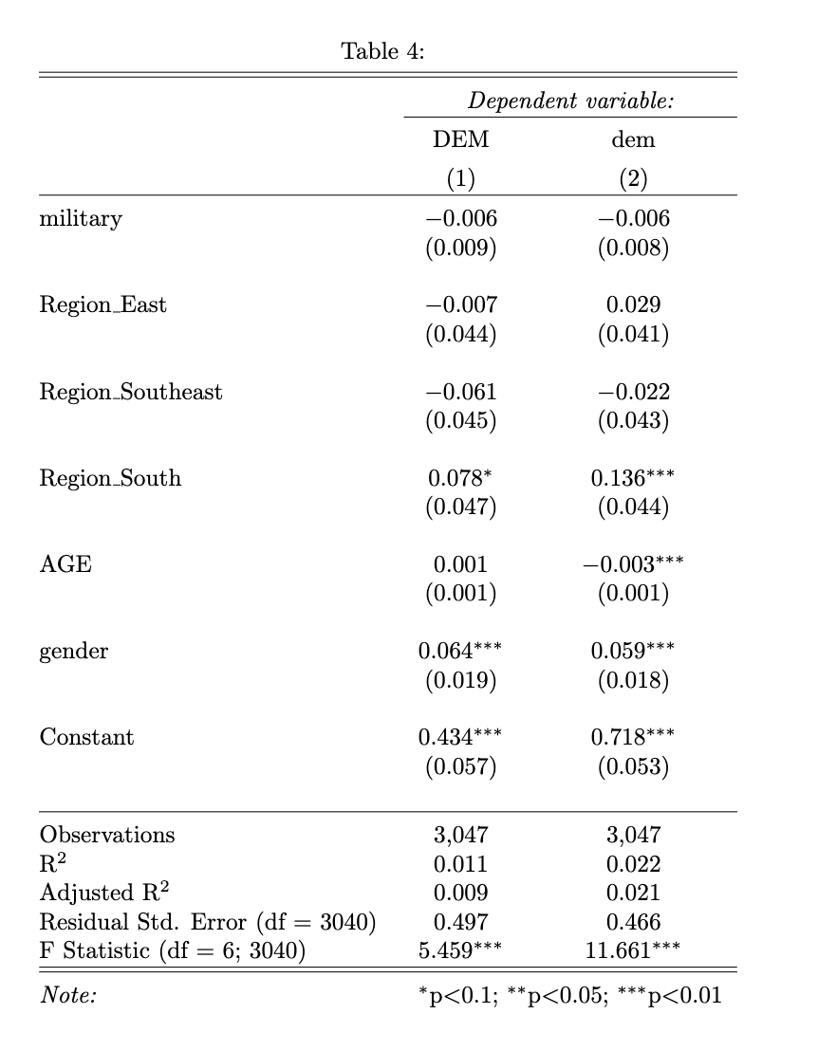
Figure 4. Effect of Military Contact on Voter Behavior

Figures 4 and 5 address my second two hypotheses relating to the effect of military contact on voter behavior. As with the figures in the previous section on immigration, each table includes two regressions, one for each of my dependent variables: DEM, voting exclusively for Democrats in 2016, and dem, voting for at least one Democrat in 2016.
The results from Figure 4 on the effect of military exposure on voting for Democrats were not statistically significant for either DEM or dem, but for both regressions, there was a negative correlation between closer contact with the U.S. military and voting Democratically. While the data is not conclusive, this correlation does support my third hypothesis that Asian Americans with closer relationships or contact with the military are less likely to vote for Democrats than those with more distant contact.
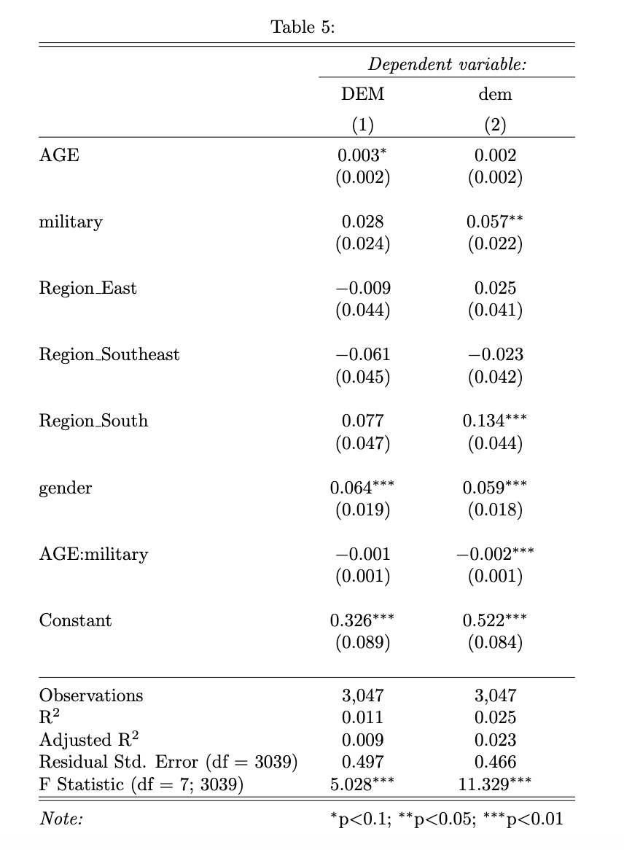
Figure 5. Effect of Age and Military Contact on Voter Behavior

The regressions in Figure 5 include an interaction term to measure the effect between age and military contact on voter behavior. In both regressions, the estimated coefficient on the interaction term between age and military contact was negative, but it was only statistically significant for the regression with dem, so I will base the rest of my analysis for this section on the second column of Figure 5.
The coefficient on the interaction term indicates that the effect of age decreases among individuals with more distant or no contact with the U.S. military by a 0.002-unit decrease. This means that there is a larger behavioral gap between older and younger Asian Americans with close military contact than among those with little to no military contact.
This contradicts my fourth hypothesis that close contact with the military would have an insulating effect against the general trend between age and voter behavior. Based on the regressions in Figure 5, rather than having an insulating effect, close contact with the military seems to increase the gap in voter behavior between older and younger generations of Asian Americans.

Chapter 6: Discussion
6.1 Hypothesis 1
Younger Asian Americans are more likely to identify as Democrats and vote for Democratic candidates than older generations.
To study the effect of immigration on differences in intergenerational voter behavior among Asian Americans, I first establish the general effect of age on voting for Democrats. Based on the regression tables in Figure 2, I find that there is significant data to support the hypothesis that younger Asian Americans are more likely to vote for Democratic candidates than their older counterparts. This is not significant when the dependent variable is voting exclusively for Democrats; the lack of significance could be attributed to Hillary Clinton’s relatively low levels of support among Democrats in 2016. Further research on this topic with data from other, more standard election cycles would be beneficial to show that this trend can be observed more generally and was not the result of special circumstances in 2016.
Previous work finds that gender and ethnic background have significant impacts on Asian American voter behavior; the coefficients on controls for gender and ethnic subgroup in Figure 2 support these findings and show that women and South Asians are more likely to vote for Democrats than men and other ethnic subgroups, respectively. The effect of age on voter behavior is still significant when holding these other factors constant, which lends greater credibility to these findings.
6.2 Hypothesis 2
The effect of recent immigration will reduce the behavioral gaps between older and younger generations of Asian Americans; recent immigrants or individuals who have spent relatively less time in the U.S. will vote more uniformly, regardless of age.
My second hypothesis focuses on the effect of immigration and intergenerational diversity among Asian Americans. I specifically focus on the differences between individuals who moved to the United States relatively early in life versus those who spent most of their life outside of the U.S. This difference in experience is especially relevant to political socialization; the country where an individual spends most of their formative years will have significant influence on what political identity they develop.
The first set of regressions estimating the interaction between the effects of age and immigration on voter behavior uses a standard definition of first, second, third, etc. immigrant status to measure an individual’s proximity to immigration. I define a first-generation immigrant as someone who was not born in the United States and moved there at some point in their life, and a second-generation immigrant as someone who was born in the United States but has at least one first generation immigrant as a parent. I find that there is the most diversity in voter behavior between older and younger Asian Americans in first generation immigrants, and that the effect of age decreases the more removed an individual is from a first-generation immigrant in their immediate family.
The second set of regressions shown in Figure 3B uses the percentage of life spent in the United States as a measure of immigration status. The results of those regressions show that the effect of age matters less among individuals who have lived in the U.S. for less of their life; in other words, among recent Asian immigrants to the U.S. there is greater uniformity in voter behavior between older and younger individuals.
Taking the results of these four regressions in combination, this suggests that among recent Asian immigrants, younger individuals break from the general relationship between age and voter behavior. Older Asian Americans vote for fewer Democrats, regardless of when they immigrated to the United States, but younger Asian Americans are significantly less likely to vote for Democrats if they have moved to the United States relatively recently. This supports further study into the concept of “1.5 generation” Asian Americans. Since 1.5 generation immigrants moved to the United States at an early age, their lived experiences often align more with second generation immigrants, despite technically being first generation immigrants (Zhou 1997). The significance of the number of years an individual has lived in the United States on voter behavior indicates that 1.5 generation immigrants will deviate from other first-generation immigrants and deserve an official separate categorization in future research.
These findings also demonstrate a need for updated research on political socialization theory that includes subjects with more diverse backgrounds. The notion that immigration stops being relevant to political socialization after a couple generations does not hold true for Asian Americans. Furthermore, the theory about the importance of parental values on shaping political behavior do not hold for families where the parents and children spent their formative years in different countries, a phenomenon which is extremely common for Asian American families. Further study on the effect of immigration on voter behavior could be beneficial for understanding other demographics, such as Latinx Americans, who also have a high proportion of foreign-born adults.
6.3 Hypothesis 3
Asian Americans with close military contact are less likely to vote for Democrats than Asian Americans with distant or nonexistent military ties.
While there was a negative correlation between military exposure and voting Democratically, I cannot make any definitive conclusions from the regressions in Figure 4 because the results were not statistically significant. It is interesting to note that the results were the same for both regressions; for the rest of the regressions I ran, the effect of the independent variable was different depending on whether the measure of voter behavior was voting for only Democrats (DEM) or voting for at least one Democrat (dem). For both DEM and dem regressions, one degree of closer military contact is associated with a 0.6% decrease in voting Democratically.
This finding, while statistically insignificant, does align with existing data on voter behavior and political ideology in the U.S. military. A Military Times poll conducted on service members in 2016 found that 40.5% of active and retired U.S. service members intended to vote for Donald Trump, compared to only 20.6% of those surveyed who intended to vote for Hillary Clinton (McCarthy & Richter 2020). There is limited information on the demographic breakdown of service members in most polls on military voter behavior, but my findings indicate that many Asian service members align with the general pro-Republican trend of the U.S. military.
The lack of significance in the findings on the effect of military exposure on voter behavior could be the result of limited data. While the 2016 CMPS did include substantial data on the relationships respondents had with active or retired service members, it did not include any other information on respondents’ relationship with the military or warfare. This could include war in the respondent’s home country, specifically war as a motivation for immigrating to the United States. There is also no information on the city or neighborhood level that could indicate a relationship with the U.S. military outside of having familial relationships with service members, such as living in geographic proximity to a military base or academy. Further research with more detailed surveys on the geographic location of respondents could provide more insight into whether military exposure is negatively correlated with voting Democratically even when one is not immediately affiliated with the military.
6.4 Hypothesis 4
The effect of greater military exposure will reduce behavioral gaps between older and younger Asian Americans; among Asian Americans with close contact with the U.S. military, older and younger Asian Americans will vote more uniformly.
I expected military exposure to have the opposite effect of immigration on differences in voter behavior across generations of Asian Americans. I hypothesized that immigration would create greater variety between older and younger voters, while military contact would insulate younger voters from external forces during the process of political socialization and result in greater uniformity in voter behavior across generations. Instead, I found that immigration and military contact have similar effects on the effect of age as a predictor of voter behavior. Among Asian Americans with closer ties to the U.S. military, there is greater diversity in voter behavior between older and younger Asian Americans than there is in groups with little or no contact with the military.
This shows that having close ties to the military does affect the political socialization process in a way that deviates from the traditional understanding that most of one’s political opinion is derived from one’s parents. This indicates a potential relationship between the effects of immigration and military exposure on voter behavior, an interaction which would be an interesting point of study for future research.
One possible explanation for the increased tendency towards voting Democratically among younger Asian Americans with military exposure is a gradual cultural shift that has occurred parallel to the increase in Asian immigration to the United States. Asian immigration to the U.S. began increasing in the 1980s, while the greater push for pan-ethnic Asian solidarity can be traced back to civil rights activists in the 1970s (Zhou et al. 2016, Kambhampaty 2020). Shifts in the demographic makeup of the country and changes to societal norms about minority groups creates space for younger Asian Americans to diversify their political views and draw from sources other than their parents.
Furthermore, over the last five years, the U.S. military has shifted away from the Republican party, in part because of the influence of Donald Trump (McCarthy & Richter 2020). While this would not directly explain the gap between older and younger service members in data from 2016, it could be indicative of a general trend away from the pro-Republican stance that the U.S. military has had in the past. If there is a broader trend of increasingly pro-Democratic alignment in the U.S. military, it would likely affect younger individuals more because their political opinions are less solidified than older service members.

Chapter 7: Conclusion
It is difficult for politicians and researchers to draw conclusions about the political behavior of all Asian Americans because of the diversity of backgrounds and experiences of this unique demographic. Past work has focused on ethnic subgroups as a means of explaining these differences, but this approach is not sufficient. Rather than looking at ethnic subgroups as the cause of this diversity, this thesis focuses on differences in exposure to immigration and the U.S. military. Immigration continues to be the force driving the growth of the Asian population in the United States, and as such, immigration and the process of assimilation are prevalent factors in the lives of many Asian Americans (Frey 2022). Military exposure is one distinct channel of Asian immigration to the United States because of the historic relationships between the U.S. military and Asia countries; this relationship continues to dictate the processes of immigration and assimilation for many Asian Americans. Understanding diversity among Asian Americans through the lens of immigration and assimilation can provide a more accurate means of predicting voter behavior that will allow politicians or researchers to better target or mobilize larger, more diverse groups of Asian Americans.
In this thesis, I find significant evidence to support that exposure to immigration and the military increased the tendency of younger Asian Americans to vote for Democrats at higher rates than older Asian Americans. The behavioral gap between older and younger individuals is largest among first-generation immigrants and recent immigrants who have lived in the U.S. for shorter periods of time. Similarly, I find that the effect of age increases among Asian Americans with more military exposure.
These findings indicate a potential relationship between immigration status and military exposure on the political behavior of Asian Americans. Both immigration and military exposure are intrinsically interlinked with the process of assimilation which introduces an entirely novel dimension to the formation of political ideology and establishing behavioral patterns. While factors like gender, socioeconomic status, and ethnic background affect the voter behavior of Asian Americans, this paper shows that assimilation and factors associated with it, such as immigration and military exposure, also have an impact and require further study.
This also suggests that existing research on differences between foreign-born and native-born individuals will not continue to hold true if current Asian immigration trends continue in the United States. As first-generation immigrants decrease proportionally compared to 1.5-generation immigrants, second-generation immigrants, etc. within Asian American communities, more research is necessary to study the effects of immigration and military exposure in a changing landscape. Further research would require new survey instruments to collect information about multigenerational households, familial relationships with war, and the geographic proximity of respondents to military bases. These factors would allow researchers to better study how and why immigration and military exposure interact and, in many cases, overlap to influence political behavior in Asian Americans.

References
Alwin, Duane F., and Jon Krosnick. 1991. “Aging, Cohorts, and the Stability of Sociopolitical Orientations Over the Life Span.” American Journal of Sociology 97(1): 169-96.
APIAVote, AAPI Data, and Asian Americans Advancing Justice. 2020. “2020 Asian American Voter Survey.” aapidata.com, https://aapidata.com/wp-content/uploads/2020/09/aavs2020_crosstab_national.pdf.
Bankston, C. L. and D. A. Hidalgo. 2016. “The Waves of War: Refugees, Immigrants, and New Americans from Southeast Asia.”. Contemporary Asian America (third edition): A Multidisciplinary Reader, 129-154. Edited by Min Zhou & A. C. Ocampo. NYU Press. http://www.jstor.org/stable/j.ctt18040wj.11.
Cai, Jieyi., and Richard M. Lee. 2022. “Intergenerational Communication about Historical Trauma in Asian American Families.” Adversity and Resilience Science 3(3), 233–245.
Do, M. 2020. Party identification, 2020. Retrieved December 2, 2022, from https://aapidata.com/party-idenfication-2020/.
Dyogi Phillips, C., & Lee, T. 2018. “Superficial Equality: Gender and immigration in Asian American political participation.” Politics, Groups, and Identities, 6(3), 373-388.
Frasure, Lorrie, Janelle Wong, Edward Vargas, and Matt Barreto. 2022. “Collaborative Multi-Racial Post-Election Survey (CMPS), United States, 2016.” Inter-university Consortium for Political and Social Research [distributor], https://doi.org/10.3886/ICPSR38040.v2
Frey, William H. 2022. “What the 2020 Census Will Reveal about America: Stagnating Growth, an Aging Population, and Youthful Diversity.” Brookings, https://www.brookings.edu/research/what-the-2020-census-will-reveal-about-america-stagnating-growth-an-aging-population-and-youthful-diversity/.
Hlavac, Marek. 2022. stargazer: Well-Formatted Regression and Summary Statistics Tables. R package version 5.2.3. https://CRAN.R-project.org/package=stargazer.
Kambhampaty, Anna Purna. 2020. “AAPI History: Activist Origins of the Term 'Asian American'.” Time, Retrieved March 8, 2013, from https://time.com/5837805/asian-american-history/.
McCarthy, N., and F. Richter. 2020. Infographic: U.S. military voting intention in 2016 and 2020. Statista Infographics. Retrieved February 18, 2023, from https://www.statista.com/chart/22761/us-military-voting-intention-in-the-november-election/.
Menegus, Dominic. 2019. “Military Bases Dataset.” U.S. Department of Transportation [Data set]. https://public.opendatasoft.com/explore/dataset/military-bases/information/.
Model, Suzanna. 2020. “Mass culture versus class culture: some reflections on The Asian American Achievement Paradox.” Ethnic and Racial Studies 43(3), 501–507.
Osborne, Danny, David O. Sears, and Nicholas A. Valentino. 2011. "The End of the Solidly Democratic South: The Impressionable-Years Hypothesis". Political Psychology, 32(1), 81–108.
Ramakrishnan, Karthick, Janelle Wong, Taeku Lee, and Jennifer Lee. 2016. “Asian American Voices in the 2016 Election: Report on Registered Voters in the Fall 2016 National Asian American Survey.” National Asian American Survey. naasurvey.com, http://naasurvey.com/wp-content/uploads/2016/10/NAAS2016-Oct5-report.pdf.
Tsai-Chae, Amy. H., and Donna K. Nagata. 2008. “Asian Values and Perceptions of Intergenerational Family Conflict Among Asian American Students.” Cultural Diversity & Ethnic Minority Psychology 14(3), 205–214.
Wong, Janelle, and Sono Shah. 2021. “Convergence Across Difference: Understanding the Political Ties That Bind with the 2016 National Asian American Survey.” RSF: The Russell Sage Foundation Journal of the Social Sciences 7(2), 70–92. www.rsfjournal.org, https://doi.org/10.7758/RSF.2021.7.2.04.
Zhou, Min. 1997. “Growing up American: The challenge confronting immigrant children and children of immigrants.” Annual Review of Sociology, 23: 63–95.
Zhou, Min, Anthony C. Ocampo, and J. V. Gatewood. 2016. “Contemporary Asian America: Immigration, Demographic Transformation, and Ethnic Formation.” Contemporary Asian America: A Multidisciplinary Reader, 3rd ed. Edited by Min Zhou and Anthony C. Ocampo. New York: NYU Press.

Appendix A
Survey Instrument
This appendix consists of the original survey instrument that I created for the purposes of collecting original data on Asian American voting behavior. I planned to distribute the survey to a random sample of Asian Americans living in Southern California, making sure that there was a variety of respondents from multiple age groups, as well as individuals with varying ties to the U.S. military. Unfortunately, the process of obtaining approval from the UC San Diego Human Review Board exceeded the length of time allotted for this project, and I was unable to run my survey and collect original data. I have included the survey instrument in this appendix to acknowledge the work I put into this aspect of this project and to show what novel data I would have aimed to gather if factors outside of my control had worked out better.

Figure A1
Survey Instrument: Intergenerational Asian American Voting Behavior
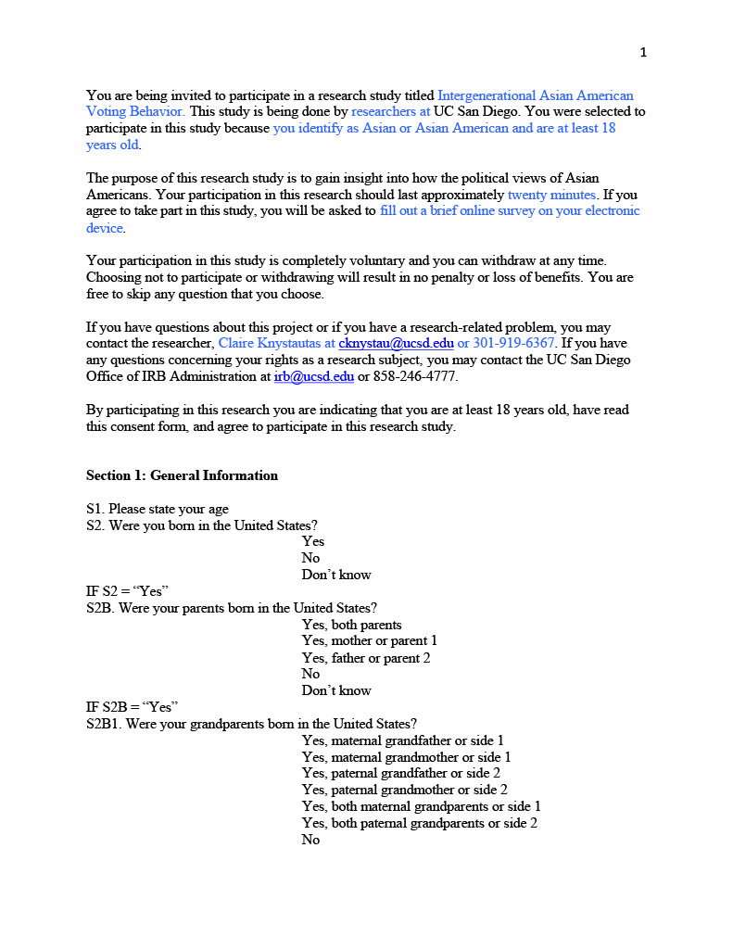
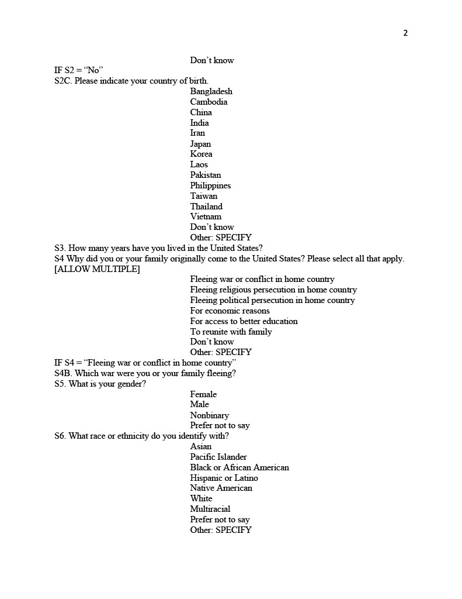
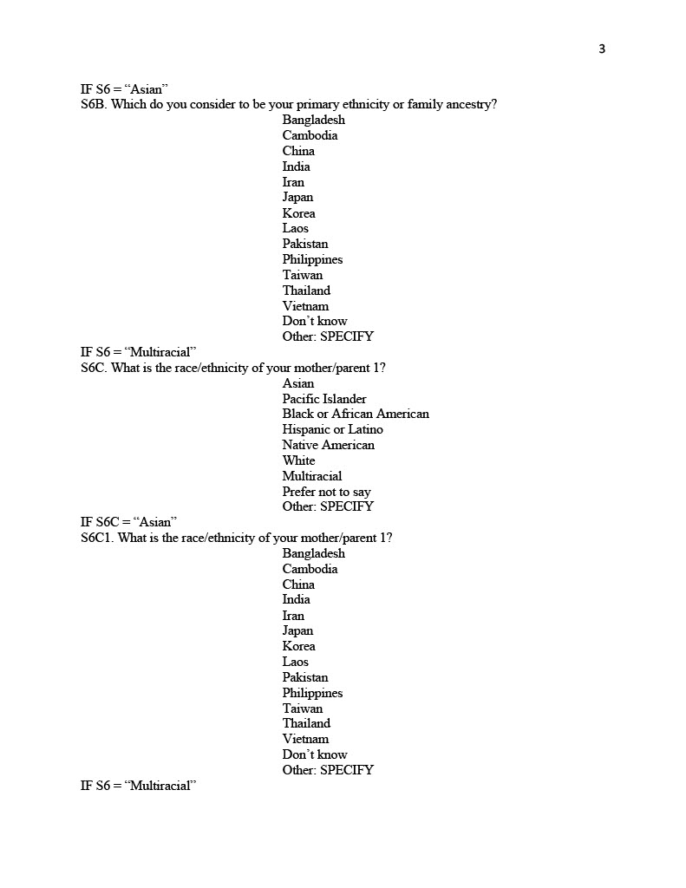
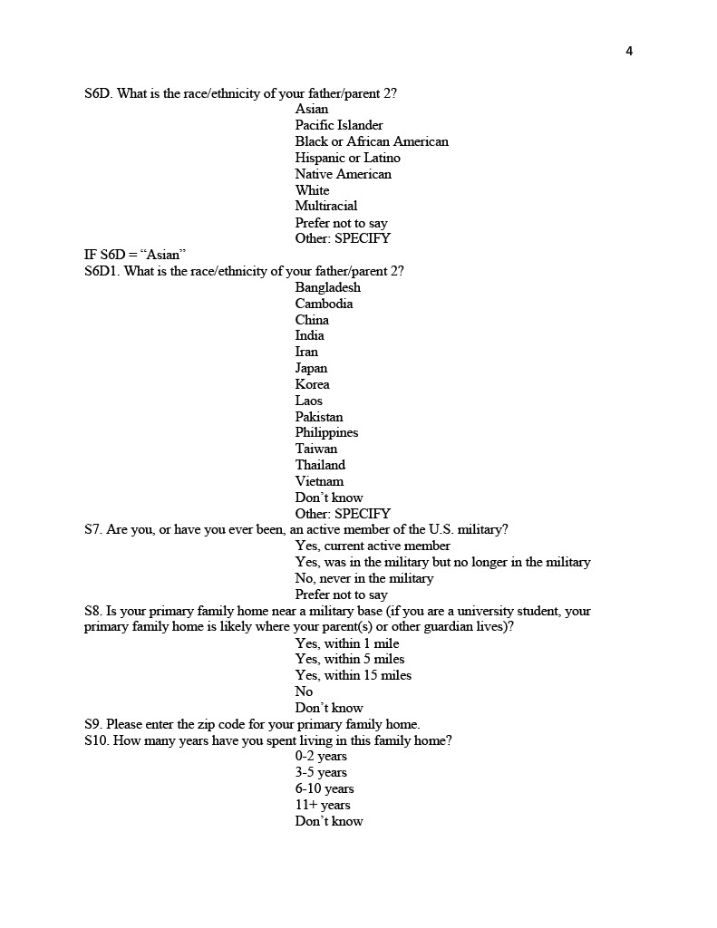
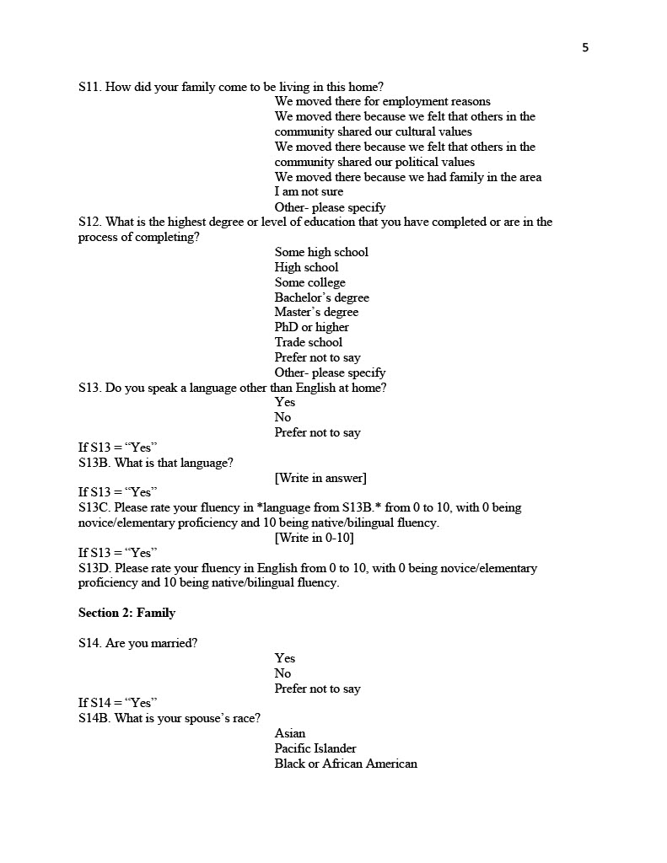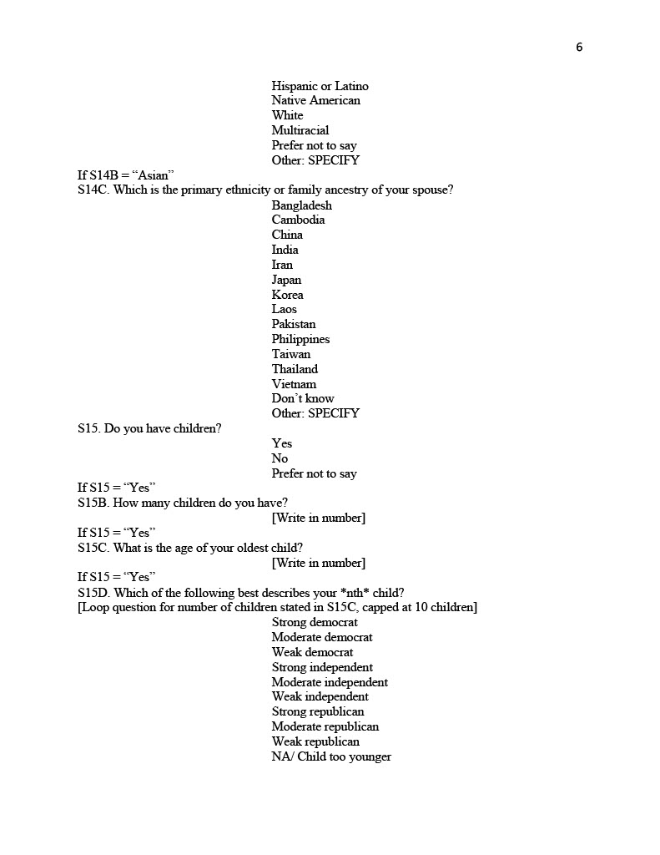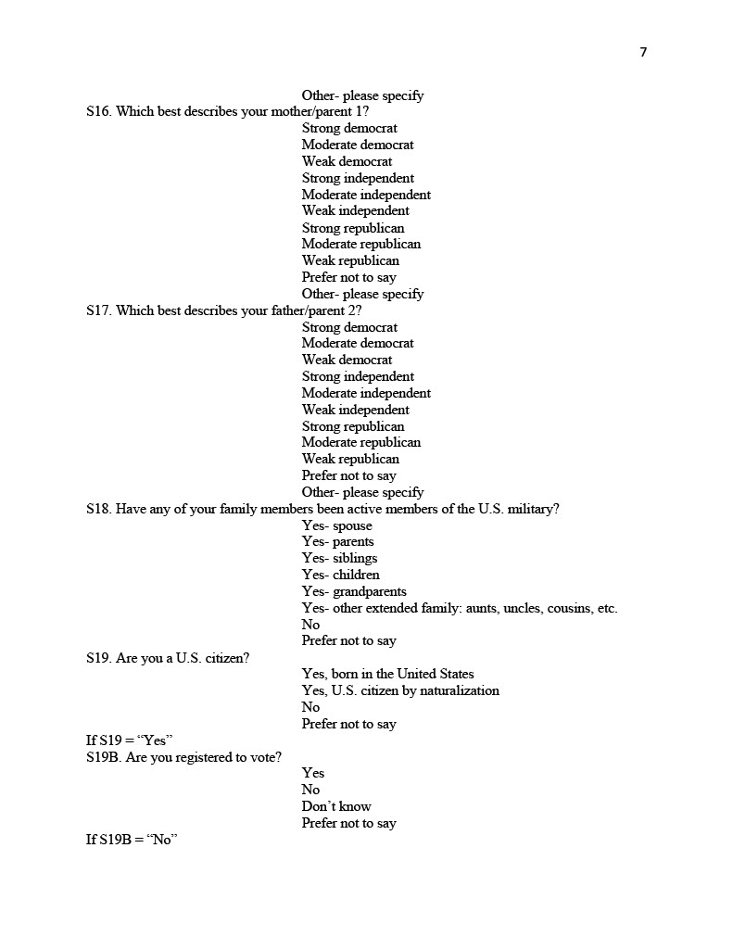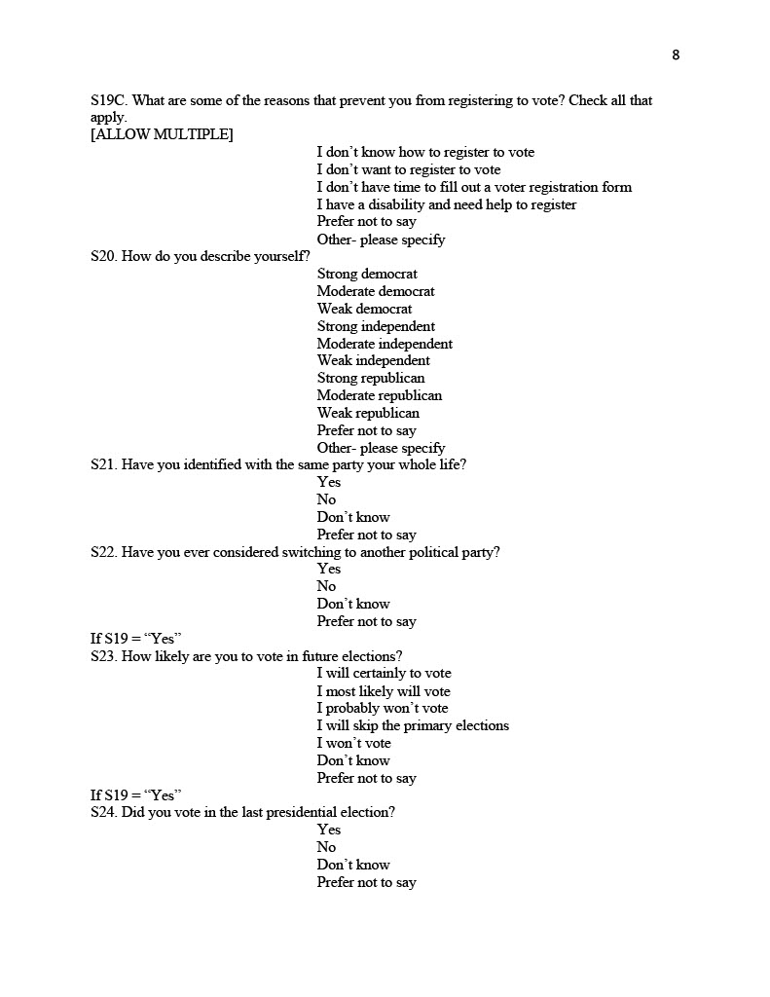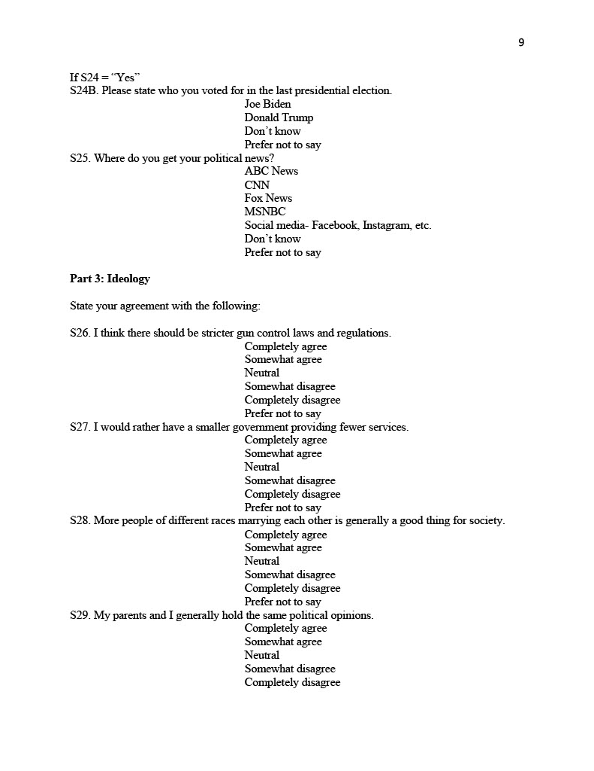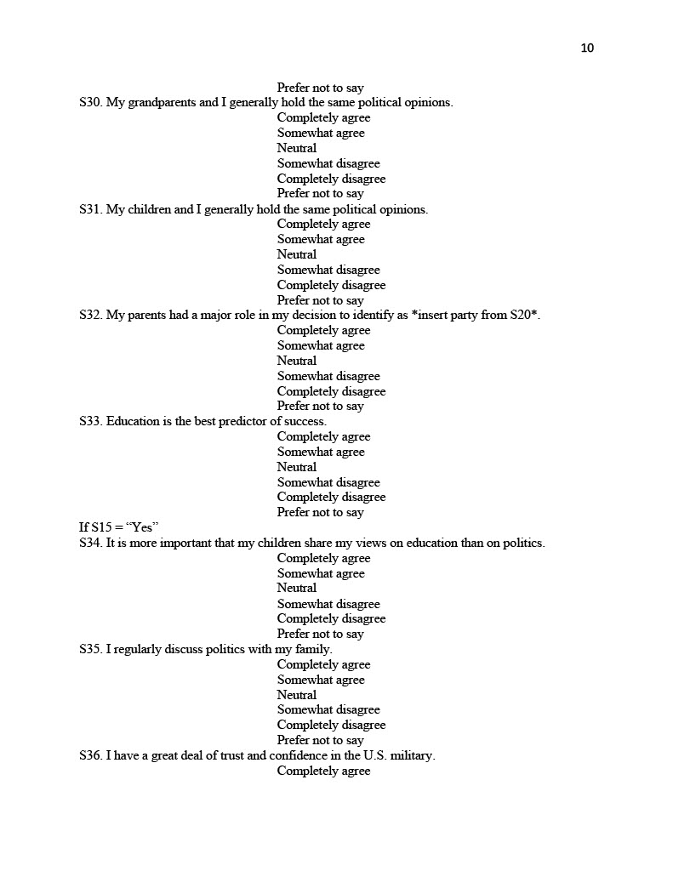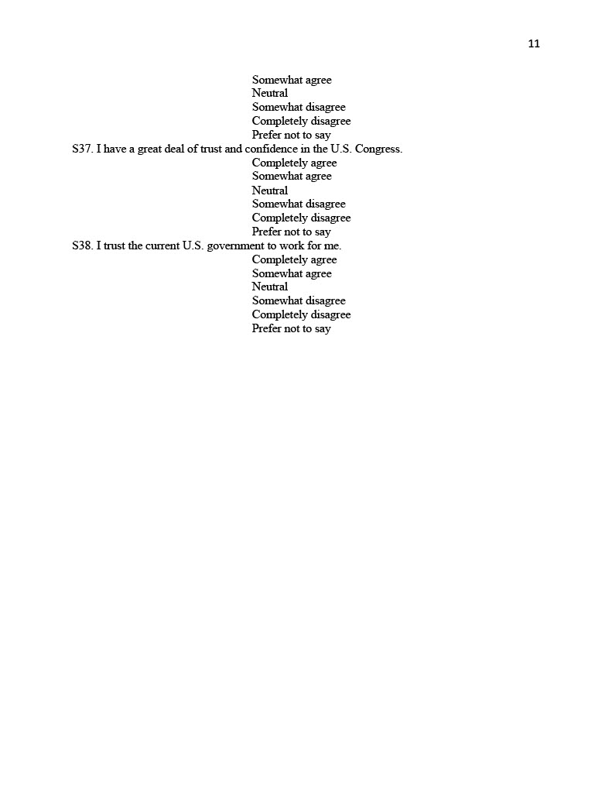
Appendix B
Survey Flyer

My research plan included an original survey, but delays with securing approval from the human subjects review board made it impossible to execute in the time frame of this project.
The survey can be found at this link, https://ucsd.co1.qualtrics.com/jfe/form/SV_0UQEpCtab4ce76m.
The table is compiled into two OLS regressions. The first focuses on the likelihood of voting exclusively for Democrats in 2016 and the second focuses on the likelihood of voting for at least one Democrat in 2016. Source: Hlavac, Marek (2022). stargazer: Well-Formatted Regression and Summary Statistics Tables. R package version 5.2.3. https://CRAN.R-project.org/package=stargazer.
Ibid.
Ibid.
Ibid.
Ibid.

